Leading Questions
Facility build out - Our KOL calls have indicated that CROs and CDMOs have significant capabilities in developing RLTs. While some amount of in-house capabilities are necessary, we wanted to better understand why such a significant build-out is needed at this stage.
Vertical integration allows for cost efficiency in early clinical manufacturing, improved efficiency in delivering medication to sites, and synergy with preclinical research needs. Sego is specifically enabled to succeed in vertical integration due to the deep experience of the team in manufacturing across stages of development and the commitment of our founding investors, Wasatch Group. Their investment in Sego includes over $6.5M in TI as part of our building lease, plus an equipment lease which is specifically structured to offset the one-time capital outlay to build a GMP suite ($3M total).
Ph 0 / Ph 1 manufacturing economics favor internal production
Production costs for the planned multi-molecule Ph 0 program are estimated to be $3M at a CDMO vs $1.4M internally. Considering Sego aims to run 6 programs through Ph 0, these costs ramp quickly making in-house capabilities much more cost effective, even when considering a $3M build cost. Below is an example scenario of costs for our planned milestones in 2028/29.
CDMO vs Sego GMP Cost | 2028 | 2029 | 2yr Total
Ph 0 Programs | 2 | 2 | 4
Ph 1 Programs | 0 | 1 | 1
CDMO Development Costs | $4,690,000 | $5,385,000 | $10,075,000
CDMO Production Costs | $1,511,700 | $3,397,700 | $4,909,400
CDMO Total | $6,201,700 | $8,782,700 | $14,984,400
Sego Overhead | $1,187,844 | $1,187,844 | $2,375,687
Sego Production Costs | $472,320 | $1,724,240 | $2,196,560
Sego Build Cost - Net of TI | $1,871,471
Sego Total | $3,531,634 | $2,912,084 | $6,443,718
Savings ($) | $2,670,066 | $5,870,616 | $8,540,682
Savings (%) | 43% | 67% | 57%

Sensitivity: 2-yr Total Savings ($) = CDMO − Sego
Ph 0 ↓ / Ph 1 → | 0 | 1 | 2 | 3 | 4
1 | ($1,382,468) | ($53,388) | $1,275,692 | $2,604,772 | $3,933,852
2 | $1,482,222 | $2,811,302 | $4,140,382 | $5,469,462 | $6,798,542
3 | $4,346,912 | $5,675,992 | $7,005,072 | $8,334,152 | $9,663,232
4 | $7,211,602 | $8,540,682 | $9,869,762 | $11,198,842 | $12,527,922
5 | $10,076,292 | $11,405,372 | $12,734,452 | $14,063,532 | $15,392,612
6 | $12,940,982 | $14,270,062 | $15,599,142 | $16,928,222 | $18,257,302

If only two programs enter Ph 0 the internal build is still favorable.
Deferring the Stage 1A GMP build to Series A (Plan B, as above) is not a viable alternative. Standing up a GMP radiopharmaceutical facility takes 12–18 months from commitment to first qualified batch. If Sego starts with CDMOs post-Seed and commits to the build at Series A (targeted mid-2028), the facility would not be ready until late 2029 at the earliest — after the first two Ph0 programs have already run through CDMO, negating the cost advantage shown above and adding the scheduling and tech transfer dependencies the build is designed to avoid. The Stage 1A facility is already in flight and on track for December 2026 completion specifically to be operational before the first clinical manufacturing need in 2028. As discussed, we believe a more realistic scenario would be to delay Stage 2 of the GMP build at the Series A, and instead supply our Ph 3 studies from a CDMO.
We can leverage academic centers in South Africa / Australia to produce doses for trials in their own centers. These sites cannot substitute for GMP manufacturing (or GMP-like manufacturing), which will be required for centers in the US and EU.
Wasatch Group investment is specifically structured to offset build costs
Wasatch has committed $20M in equity and build investment support for the Seed round. $6.5M of the total build costs will be taken as TI within the building lease agreement, offsetting ~40% of the proposed $15M total build cost (the impact of this is shown above as the “Build cost Net of TI”). Further, all scientific equipment purchased, including $2.6M of equipment for the GMP suite, will be structured in an equipment lease, rather than a one-time, full cost outlay for Sego. This keeps our CapEx low, with a marginal increase in operating cost to service the leases. Wasatch has further demonstrated their commitment to Sego’s success by an option in the IRA to another $20M equity contribution to the Series A.
We have the manufacturing experience to operate a world-class GMP facility
This team has built and operated the facilities we are now replicating; that experience compresses the build timeline and reduces execution risk relative to a team standing up RLT manufacturing for the first time.
Greg has taken several radiopharmaceutical diagnostics and therapeutics through clinical development and eventual approval. He has experience in the tech transfer of multiple products to CDMOs and radiopharmacies in the US and EU, including ¹²³I PARPi Tx, ²²⁵Ac SSTR2 Tx, ¹⁷⁷Lu SSTR2 Tx, ¹⁸F PARPi Dx , ⁶⁸Ga PSMA Dx and US approval of ^{99m}Tc DMSA Dx. Brandon Buckway joins from the University of Utah, where he ran radiochemistry and built out a GMP manufacturing facility. It is one of the few commercial GMP radiopharmacy centers supplying the entire Mountain West and was responsible for being listed as one of the early ANDA/NDA manufacturing sites for several commercial radiopharmaceutical products including FDG, Axumin, Vizamyl, Pylarify, Posluma, and Cerianna. Jeevan scaled manufacturing at Advanced Accelerator Applications (AAA) and at Novartis, including commercial supply for Lutathera and Pluvicto. Richard has translated three ⁸⁹Zr labeled antibody diagnostics to FIH studies via both academic and CDMO manufacturing routes.
Additional strategic advantages of internal GMP supply for Ph 0 / Ph 1
Supply chains are simpler & logistics are derisked when supply is integrated from isotope production to delivery at sites: Placement of manufacturing capabilities near Nusano and the SLC airport allow Sego to maintain full control of isotope delivery and manufacturing scheduling, eliminate decay losses, and reduce scheduling/logistical fragility of the supply chain. In contrast, moving to CDMOs would extend timelines 12 months based on the founding team’s experience of identifying and securing CDMO capacity for six separate RLT programs, completing six independent tech transfers (each requiring analytical method validation at the CDMO site), and navigating CDMO scheduling constraints. Furthermore, we intend several of our clinical sites to be local, including the Huntsman Cancer Center, which is the only National Cancer Institute-Designated Comprehensive Cancer Center serving Utah, Nevada, Montana, Wyoming, and Idaho.
Simple regulatory approach: Supplying trials from a single site, across stages, keeps regulatory requirements easier to meet. It will be simpler for Sego in the long run.
Synergy with preclinical radiochemistry needs: Hot laboratory infrastructure is differentiating in the preclinical space; few CROs have the capacity to run in vitro or in vivo hot work to high quality. Shared radiation shielding, HVAC, waste handling, and personnel access lower construction cost and ongoing OpEx, as well as molecule supply for preclinical studies. Further, this capital is amortized across all six programs we intend to develop.
4x value premium for RLT companies with manufacturing capabilities: Acquisitions of companies like Fusion, RayzeBio and Point commanded 4x the upfront value vs comparable companies without manufacturing, such as Mariana, 3B Pharma and others. In our experience, big pharma with existing RLT manufacturing capabilities are either looking to diversify their manufacturing footprint or looking to expand capacity. New entrants to the field would be attracted to an end-to-end RLT approach.

Timeline and in-licensing molecules - A significant number of the 40 prioritized targets have chemical matter in the public (and private) domain. Many RLT companies are leveraging these molecules to rapidly advance to Ph0 studies. Can you explain in detail how you are thinking about in licensing or leveraging this work to speed up time to Ph0?
We are focused on rapid entry to the clinic by leveraging all the above approaches: (1) leveraging known chemical matter to accelerate programs, specifically ACP3 and KLK2 (2) exploring the abundance of in-licensable programs in a rigorous manner (3) reserving completely de novo discovery efforts for targets where there is no alternative.
Leveraging known material: For ACP3 and KLK2, we are leveraging existing chemical matter rather than running de novo screens. For ACP3, prior art on small-molecule inhibitors and known binding interactions support structure-based design and focused library construction for accelerated hit ID. For KLK2, published small peptides as broad kallikrein-family inhibitors give us starting points for KLK2-selective variants. Hit-finding for both programs is expected to take 3–4 months rather than the 9–12+ months of a full de novo campaign; FTO evaluation runs in parallel from day one.
In licensing: Interaction with our deep network in the RLT space has highlighted the abundance of in-license opportunities that could accelerate us to the clinic, and the strategic value in de-prioritizing an internal program in favor of an accelerating BD opportunity. In the last 3 months, we have spoken to dozens of potential partners and have engaged on 5+ assets either near clinic ready or with FIH data, though ultimately these programs did not meet our internal diligence criteria for in-licensing. We are still evaluating other proposed programs and we are confident that continued search & evaluation is likely to unearth a program that meets our target selection criteria, comes with a strong data package & deal economics, and would accelerate Sego toward FIH entry. We are actively continuing outreach to Chinese RLT companies, European & American academic centers & beyond.
Given the potential for in-license, we have reviewed our six targets in greater detail. We have deprioritized GCC in order to make room for an in licensed asset. This deprioritization is based on GCC ranking in our internal scoring system.
In parallel to our continued outreach, we are leveraging our original 40 evaluated targets, for two reasons: (i) to pre-identify targets we are interested in for S&E efforts, and (ii) to identify a back-up candidate to replace GCC as an internal program, should we not identify an in-licensable program. We are focused on deep diligence of a number of additional tight/adherens junction proteins (e.g. claudins, cadherins, or nectins) and apically expressed targets (e.g. mucins), as these best fit our tumor-specific accessibility paradigm for target selection.
De novo screening: For the remaining three targets (CLDN1, MUC1-C, CEACAM5), the biology is strong — these are high-conviction targets selected on the same RLT-bespoke criteria as ACP3 and KLK2. However, existing chemical matter does not meet our preferred format requirements, specifically cyclic peptide or small molecule. For both CLDN1 and MUC1-C, we plan to leverage naturally occurring homo- and hetero-typic interactions, respectively, to derive cyclic peptide starting points and advance them rapidly through medicinal chemistry. De novo discovery will complement these efforts across all three programs.
Additional Questions
Can you outline how you plan to run your Ph0 studies such that they most accurately predict biodistribution, toxicity, and efficacy of the final therapeutic isotope?
Our Ph 0 design is purpose-built to generate the most accurate prediction of biodistribution, toxicity, and efficacy of the final therapeutic isotope by combining (1) a two-cohort Ph0 study that performs quantitative dosimetry with ¹⁷⁷Lu as the imaging, (2) a rigorously calibrated quantitative SPECT workflow for more accurate data collection, and (3) validated dosimetry modelling approach that translates ¹⁷⁷Lu Ph0 dosimetry into a Ph1 more relevant starting dose and escalation plan for ²²⁵Ac.
- Quantitative human dosimetry with ¹⁷⁷Lu in Ph 0
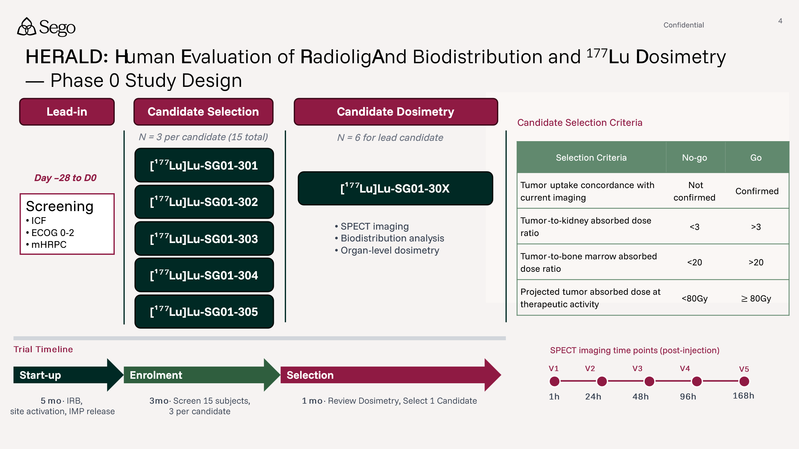
Above is the Ph 0 design. The study runs two sequential cohorts: (i) a Candidate Selection Cohort of 3 patients per peptide across 3–5 candidates, evaluated against pre-specified criteria for tumor uptake, retention, organ-at-risk washout, and predicted absorbed dose; (ii) a Candidate Dosimetry Cohort of 6 additional patients per passing candidate to refine dosimetry and select the lead. This operates under FDA's Exploratory IND (link) and Microdose Radiopharmaceutical Diagnostic Drugs (link) frameworks. Because the cold mass is at microdose levels, the clinically relevant toxicity signal at this stage is radiation, not pharmacologic.
¹⁷⁷Lu is used as the Ph0 imaging isotope because its gamma emissions are well-suited to quantitative SPECT, allowing us to capture the full biodistribution and time-activity curves out to ≥7 days for each organ at risk and for tumor. Because the targeting vector, not the radiometal, drives pharmacokinetics, the ¹⁷⁷Lu time-activity data accurately represent how the molecule distributes and clears in humans. Further, ¹⁷⁷Lu is also used easily because it has a US DMF, MA in EU. Therefore, toxicity can accurately be predicted based on biodistribution, PK and dosimetry of the ¹⁷⁷Lu agent.
(2) Ensuring accurate SPECT quantification in Ph 0 increased prediction accuracy
Accurate dosimetry prediction is only meaningful if the underlying SPECT quantification is itself accurate. We have developed a site feasibility assessment protocol that includes confirming three calibration steps of SPECT/CT scanners to ensures activity concentration (Bq/mL) is recovered correctly at the voxel level: (a) scanner calibration, (b) isotope-specific calibration & (c) volumetric phantom calibration. Centers using Lutathera or Pluvicto will have already calibrated their SPECT/CT for ¹⁷⁷Lu, creating efficiency. With all three calibrations in place, kidney absorbed-dose accuracy is typically ~10% (1 SD, similar for other large organs), translating the 23 Gy EBRT limit to 23 ±2.5 Gy, where the accuracy is well within the FDA tolerance for exposure.
(3) Validated dosimetry modelling approaches allow extrapolation from ¹⁷⁷Lu data to Ph 1 starting doses for ²²⁵Ac
The ¹⁷⁷Lu-derived time-activity curves and organ/tumor residence times are the patient-specific input from which we calculate predicted ²²⁵Ac dosimetry using established & accurate methods. Because peptide pharmacokinetics are driven by the vector and not the radiometal, the ¹⁷⁷Lu residence times are re-weighted by the ²²⁵Ac decay scheme and emission energies (alpha plus daughters) to project ²²⁵Ac Gy/GBq for each organ at risk and for tumor. This enables us to define a therapeutic window that does not exceed accepted EBRT critical dose limits from the Ph 0 data. Because this re-weighting is standard in RLT, driven by physics, and enables definition of a therapeutic window directly, we can justify a specific, higher ²²⁵Ac more relevant starting dose vs. if we had no human data on the molecule.
While these approaches are established for acute toxicities and initiation of Ph 1 studies, prediction of long-term toxicity from Ph 0 data would be highly appealing in derisking assets. To address these gaps, Sego is developing an in silico Ph1 platform trained on historical RLT patient datasets and combined with our Ph0 dosimetry to simulate dose escalation in virtual cohorts and inform efficacy and long-term tolerability.
After selecting a lead imaging molecule, how much more optimization is required for the final isotope and does this significantly change the properties observed at Ph0?
The Ph 0 study uses ¹⁷⁷Lu as the imaging isotope for the dosimetry cohort. Switching to the desired therapeutic isotope, ²²⁵Ac, requires minimal further optimization because the peptide scaffold (affinity, internalization, clearance kinetics) does not change between isotopes as they are both 3+ lanthanides and chelator DOTA in the same way. PK properties observed at Phase 0 have proven predictive of therapeutic-dose behavior in Lutathera and Pluvicto.
The primary variables are chelator compatibility, radiolabeling conditions, and formulation stability, all of which will be explored preclinically across different potential therapeutic isotopes in parallel (or in advance) of an FIH imaging study. To minimize the optimization gap between imaging and therapeutic isotope, Sego will utilize a single multi-radionuclide chelator (DOTA/DOTAGA derivatives) compatible with ⁶⁸Ga, ¹⁷⁷Lu, ¹⁶¹Tb, and ²²⁵Ac. This removes the chelator variable when switching isotopes and avoids separate manufacturing development for each pairing.
How do you view the long-term positioning of RLTs in the oncology treatment paradigm? Do you foresee a future where RLTs routinely become first-line treatments? How do you imagine we will overcome current delivery challenges?
RLT will absolutely become a backbone oncology modality, used earlier in the disease course and in combination. The clinical logic for earlier use is straightforward: earlier-line patients have better organ function, a larger cumulative dose budget, and longer survival horizons, all of which amplify RLT's benefit-to-risk ratio. Lutathera and Pluvicto established the foundational validation and logistics, and we are watching Pluvicto move into earlier treatment lines in real time.
Further, RLT’s are combinable with other therapies, allowing for creativity in dosing regimens & placement in treatment paradigms. RLT's MOA of radiation-based DNA damage is orthogonal to most oncology drug classes. It drives toxicity in specific organs at risk (kidney, bone marrow, salivary gland) rather than the systemic mechanisms that limit IO agents, ADCs, TKIs, and BiTEs. Toxicity overlap with other modalities is rare. The orthogonal MOA and lack of overlapping toxicities make RLT a practical combination partner: sequence it around chemotherapy cycles, pair it with IO agents in IO-primed tumors, or run it during TKI drug holidays. Chemo-radiation is already SoC in multiple solid tumor settings; peptide RLT follows the same logic, with far fewer downsides to neighboring healthy tissue.
The delivery challenge is logistical and regulatory. Nusano adjacency solves the isotope access and scheduling fragility problem for Sego's clinical studies. Radiopharmacy network partnerships (a model the team has direct commercialization experience with from prior FDA-approved products) solve the last-mile delivery problem at scale. Regulatory frameworks for theragnostic companion diagnostics are maturing rapidly, with FDA's August 2025 draft guidance on dosimetry-based patient selection moving the field toward the quantitative framework Sego is already building. Hospital networks, including Utah’s Huntsman Cancer Institute, are investing rapidly in theragnostic centers & treatment suites. Taken together, first-line positioning is feasible within this decade for the right targets and indications.
What do you foresee as the biggest challenges in the molecule optimization process? Are there any parts of the process that have historically been bottlenecks in the development of approved therapies like Pluvicto and Lutathera?
The two structural challenges in RLT small molecule / peptide optimization are (i) over-optimizing ligand affinity in isolation rather than the whole molecule and in the absence of PK, and (ii) reliance on animal models that do not predict human pharmacokinetics.
On whole-molecule performance: the relevant unit is not the ligand alone but the full construct ligand, linker, and chelator, with the metal bound. Optimizing ligand affinity in isolation, and then appending the linker and chelator late, routinely produces candidates that perform well in binding assays and fail in vivo. The linker and chelator affect physicochemical properties (charge, lipophilicity, solubility), clearance kinetics, plasma stability, and intracellular behavior after internalization. Programs that treat these as afterthoughts, rather than co-optimizing from the start, waste cycles and narrow the compound set prematurely.
On animal predictability: preclinical models are consistently poor at predicting human pharmacokinetics in RLT. Kidney uptake and retention is the clearest example: programs with low murine kidney exposure have observed higher human retention, and programs with high preclinical kidney signal have seen rapid clearance in patients. It means that hard go/no-go decisions based on mouse kidney data alone are potentially unreliable, and that the field has historically committed to a single lead before having human evidence of its safety margin.
How Sego mitigates both:
First, we co-optimize the whole molecule from day one. Cold optimization is structured around full ligand-linker-chelator conjugates loaded with a cold metal, not bare ligands. ICP-MS-based multiplexed in vivo PK allows us to screen many constructs simultaneously for tumor and kidney uptake without radiolabeling — we run this across diverse compound series. This surfaces whole-molecule performance issues early, before committing to radiosynthesis.
Second, we apply explicit stage-gate criteria at every transition. No-go criteria at H2L cover affinity, selectivity, physicochemical properties, and cellular behavior. No-go criteria at LO cover early in vivo behavior of compounds leveraging ICP-MS studies to get a strong grasp of SAR in vivo. In FIH enabling, we directly quantify and gate on dosimetry. Candidates that fail these gates are cut. The intention of these gates is to surface a set of 3-5 molecules with diverse properties for FIH imaging studies.
Third, we resolve animal predictability at the source by getting into humans with a diverse molecule set. The Phase 0 design carries 3–5 candidates from distinct chemical series into first-in-human imaging simultaneously. Human tumor uptake, organ-at-risk dosimetry, and clearance kinetics select the development candidate. We do not commit to a single lead on preclinical data and hope it translates; instead, we use FIH data on multiple molecules for a single target to pick the best one.
Can you project what a Series A raise would look like and what outcomes it would fund to?
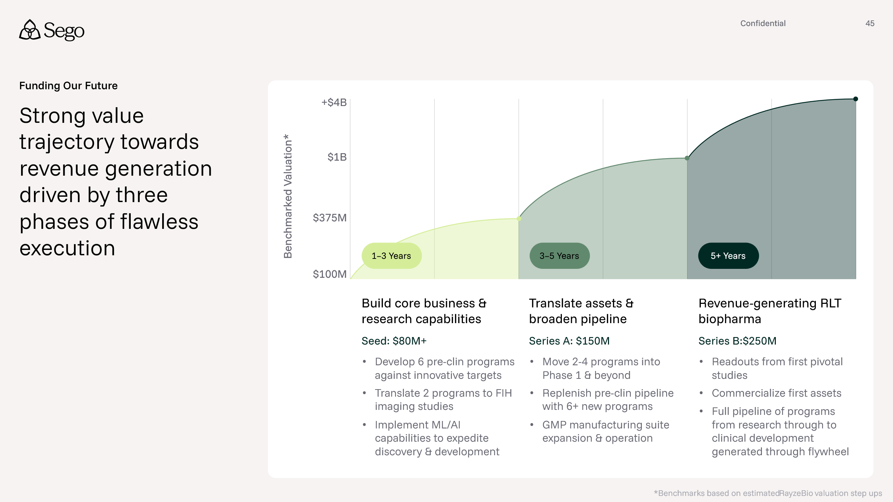
We expect to raise a Series A of $150M which will support 2-4 programs in clinical development, replenishing the preclinical pipeline with new programs & potentially building out of additional internal GMP capabilities to support Ph 2 and Ph 3 clinical development (this activity may also be conducted at a CDMO). We anticipate that 2 programs will reach clinical efficacy readouts (Ph 1/2) and 2 additional programs will enter FIH studies, financed by the Series A. Clinical efficacy data generated during the Series A will be highly valuable and transactable based on recent RLT benchmarked transactions. For example, RayzeBio was sold for $4.1B with Ph 1 data on SSTR2, and Fusion for $2.4B with Ph 1 data on PSMA. Notably, both were fast follow programs, and data on one of Sego’s novel targets may prove even more valuable to investors or potential BD partners.
Do you have plans to expand isotope use to others apart from Actinium and Terbium? How do you view the evolving landscape of isotope options in radiopharma and how would this enable or limit BD partners?
²²⁵Ac and ¹⁶¹Tb are Sego's primary therapeutic isotopes; ⁶⁸Ga and ¹⁷⁷Lu are the paired imaging and benchmarking isotopes. We are not planning to expand into additional isotopes in the near term, and the rationale is deliberate rather than a resource constraint.
²²⁵Ac's alpha emission provides 4 alpha-decay daughters per chain, a kill density no beta emitter can match. ¹⁶¹Tb adds a beta-plus-Auger combination with twice the per-GBq tumor absorbed dose of ¹⁷⁷Lu in head-to-head PSMA dosimetry, suited for indications with mixed disease burden including micrometastases and CTCs. Together, the two isotopes cover the full spectrum of clinical scenarios: alpha for high-copy-number, high-internalization targets where the therapeutic index supports it; ¹⁶¹Tb where the on-target/off-tumor expression profile or disease burden distribution favors more forgiving dosimetry. A single multi-radionuclide chelator (DOTA/DOTAGA) is compatible with all four, removing manufacturing complexity when switching across the pipeline.
For BD partners, this two-isotope strategy is commercially enabling rather than limiting. ²²⁵Ac and ¹⁶¹Tb are both actively characterized under FDA regulatory frameworks, and ¹⁶¹Tb in particular is attracting DMF filings from multiple global suppliers. Partners who want alpha exposure get a clinical stage ²²⁵Ac program; partners building for broader market coverage get ¹⁶¹Tb's more favorable dosimetry profile at scale. The single-chelator architecture further simplifies tech transfer. Sego will reassess isotope expansion if a specific target or indication biology warrants it, but will not add isotopes ahead of that clinical driver.
What is your opinion on shorter vs longer lived isotopes and balancing supply and waste chain tradeoffs?
Lutathera and Pluvicto both use ¹⁷⁷Lu (7.2-day half-life) and are approved and commercially successful. No approved RLT program has converged on a shorter-lived isotope. Sego's position is that isotope selection should be driven by maximizing tumor dose while minimizing exposure to organs at risk.
Sego's small-molecule and cyclic-peptide constructs are designed to be retained in the tumor and rapidly cleared renally. They favor longer-lived isotopes that maximize cumulative tumor dose. A shorter-lived isotope, even with a higher dose rate, will not deliver as much dose to the tumor compared to ²²⁵Ac.
On supply and waste chain: ²²⁵Ac supply had been recognized as a bottleneck for the field, and Sego's strategic relationship with Nusano provides a structural advantage in access and scheduling. ¹⁶¹Tb supply has improved over the past 12 months, with multiple suppliers pursuing cGMP qualification and DMF filings. Waste handling for both isotopes is governed by standard radioactive materials regulations and does not represent a differentiated operational challenge versus other therapeutic radionuclide programs.
Can you walk us through the characteristics of ACP3 and KLK2 that you believe will make for a differentiated asset from Pluvicto/PSMA? How will your ACP3/KLK2 molecule stack up against the ACP3/KLK2 RLTs that are already in clinical trials?
ACP3 and KLK2 differ from Pluvicto/PSMA on three axes: expression profile across stages of PC, target expression in healthy tissues and organs at risk, and therapeutic index. Both are expressed in PSMA-low and PSMA-negative prostate cancer patients (~15% of high-risk mCRPC), expanding the addressable population beyond Pluvicto's reach.
ACP3: expression is maintained in ~95% of prostate cancer patients across disease stages, with a lack of expression in salivary gland and kidney, which are the tissues that drive Pluvicto's two dose-limiting toxicities. First-in-human imaging data shows strong tumor uptake with significantly enhanced on-target/off-tumor uptake versus PSMA-targeted agents. BMS/RayzeBio's OncoACP3 program uses a non-internalizing small molecule, creating opportunity for Sego to deliver a more efficacious, internalizing molecule where intracellular delivery amplifies Auger and alpha-emission DNA-damage kinetics of ¹⁶¹Tb and/or ²²⁵Ac. Furthermore, we are developing potential covalent binders to ACP3 that could also enhance retention of the RLT. Finally, OncoACP3 is a racemic mixture that could generate issues with downstream CMC. Sego's initial intent is a randomized comparator pivotal against Pluvicto in the full mCRPC population (not enrichment for PSMA-low/negative) because the expression and TI advantages support a superiority hypothesis across the full population. Given the likely wide therapeutic index, we also intend to bring our ACP3 program rapidly into earlier lines of therapy.
KLK2: expression is restricted to the healthy prostate with substantial overexpression across prostate cancer stages, maintained in PSMA-negative disease. JNJ's antibody program experienced ILD and hematologic toxicity driven by antibody pharmacokinetics (long half-life, Fc biology, cumulative lung dose) rather than target biology. Sego's short-circulating cyclic peptide approach eliminates all three mechanisms: short circulating half-life reduces prolonged blood residence, there is no Fc biology, and no pulmonary dose accumulation from the targeting vector. Phase 0 imaging will confirm lung dosimetry before any therapeutic activity is given. KLK2's earlier-disease expression profile (earlier-stage disease, BCR-triggered interventions) and PSMA-negative coverage represent additional competitive differentiation absent from PSMA-targeted programs. Like ACP3, we intend to prove superiority to Pluvicto and expand into earlier lines of treatment.
For each of your targets, can you outline: 1) Why this is more suited to the RLT modality than ADC? 2) How you will position against ADCs against the same target (if applicable) and 3) What you view as the value inflection point? E.g. Ph0, 1, 2, 3+
RLT outperforms ADCs on mechanism, toxicity predictability, and resistance profile for Sego's target set, with earlier value inflection (Ph 0) vs. ADCs against the same targets.
Suitability to each modality: ADCs depend on receptor-mediated internalization, intracellular trafficking, and enzymatic payload release. Each step is a failure mode. Efficacy and toxicity are sensitive to linker stability, payload class, and tumor cell biology. IgG-based ADCs carry additional scaffold-driven risk: Fcγ receptor engagement promotes non-tumor uptake, immune activation, and prolonged tissue exposure. Saturating mass doses in combination with prolonged tissue exposure limit the ability to reduce off-tumor exposure to target expressing and non-expressing tissues. This has historically produced narrow or unpredictable therapeutic windows and off-target toxicities (ocular, pulmonary, GI). Resistance mechanisms including drug efflux and impaired internalization limit durability.
RLT delivers cytotoxicity through localized radiation emission, independent of cell cycle status and intracellular payload processing. Alpha particles from ²²⁵Ac cause irreparable DNA double strand breaks. ¹⁶¹Tb emission profile contains beta-minus particles that cause single and double strand breaks in addition to Auger and conversion electrons that add high-LET damage at short distances. Crossfire from both isotopes addresses tumor heterogeneity without requiring receptor expression on every cell. Sego's radioligands are administered at non-saturating mass doses with rapid renal clearance, preserving the tumor-to-normal tissue dose ratio that defines the therapeutic window. The same logic holds across all six programs.
Positioning against ADCs on the same antigen: Where ADC programs exist on Sego's targets (CEACAM5, MUC1-C, CLDN1), RLT offers an orthogonal MOA and distinct toxicity profile, enabling combination sequencing rather than purely competitive positioning. RLT can be deployed after ADC progression or co-developed as a treatment backbone. Clinical efficacy of CEACAM5 ADCs has potentially been limited due to the lack of internalization and intracellular payload release, while historical MUC1 ADCs have bound aberrantly glycosylated MUC1-N which is shed and can reduce efficacy.
Value inflection point: Phase 0 imaging is the primary value event across the pipeline. Human dosimetry confirming tumor:kidney >3 and tumor:marrow >20, with evidence of tumor uptake and favorable organ-at-risk exposure, transforms a preclinical asset into a development candidate with a quantified dosimetry and therapeutic index in the patient population. This data package is directly decision-useful for BD partners, investors, and regulatory strategy. Phase 1 proof-of-efficacy signal is the second inflection; pivotal design and partnership discussions follow.

